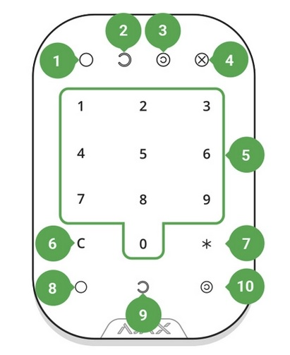
- Armed mode indicator
2. Disarmed mode indicator
3. Night mode indicator
4. Malfunction indicator
5. The block of numerical buttons
6. “Clear” button
7. “Function” button
8. “Arm” button
9. “Disarm” button
10. “Night mode” button
To activate KeyPad, touch the keyboard: the backlight will switch on, and the beeper sound will indicate that KeyPad has woken up.
For regular arming -disarming press the *, enter code and press button 8 for arming system or button 9 for disarming system
When incorrect passcode is entered three times during 30 minutes, KeyPad locks for the time preset by the administrator user. Once KeyPad is locked, the hub ignores any commands

